1st thing you need to do is download your Favorite MT5 app.

If you have no idea where to download, then go to metatrader5 web site

<https://www.metatrader5.com/en/download>

Once downloaded double click an install

Once it gets done click on Finish

Next you need to setup a demo account

Next click Next and setup a Demo Account.

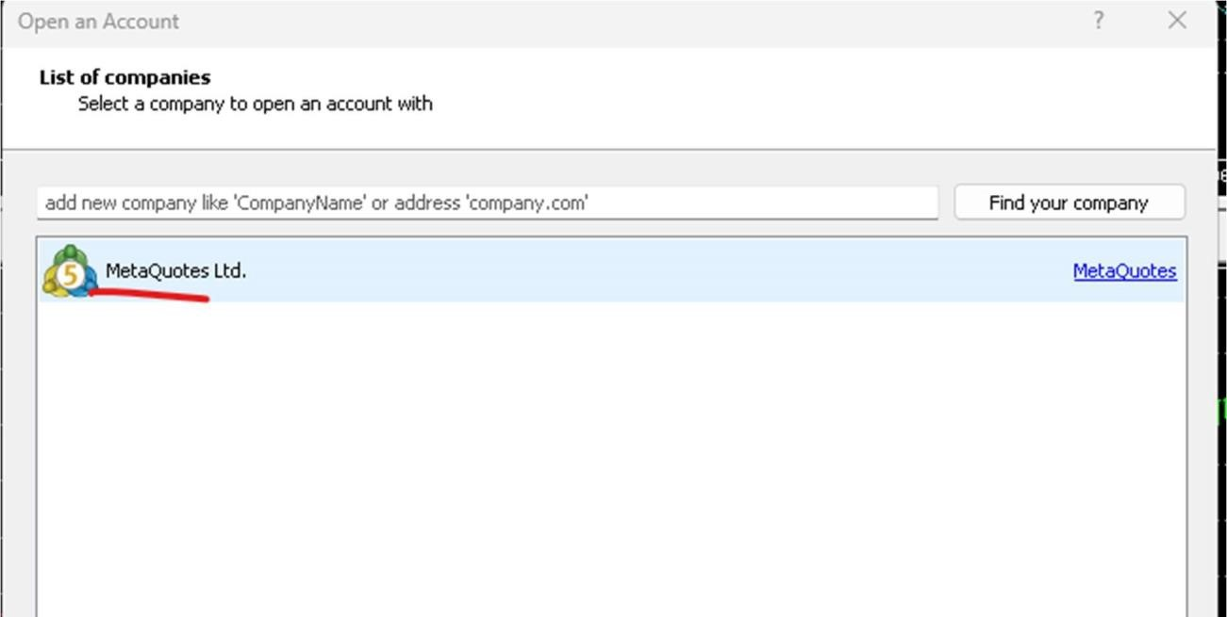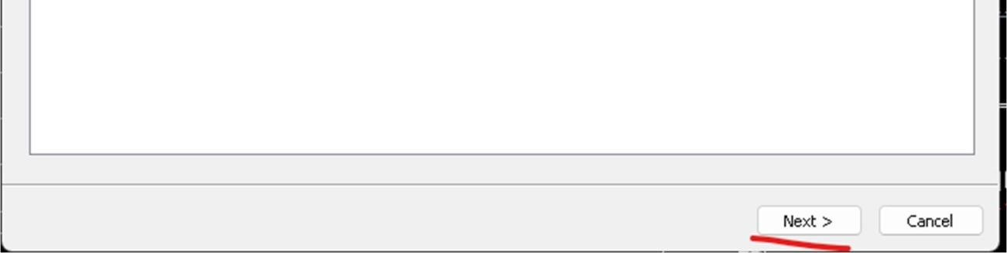

Input your information then click next.

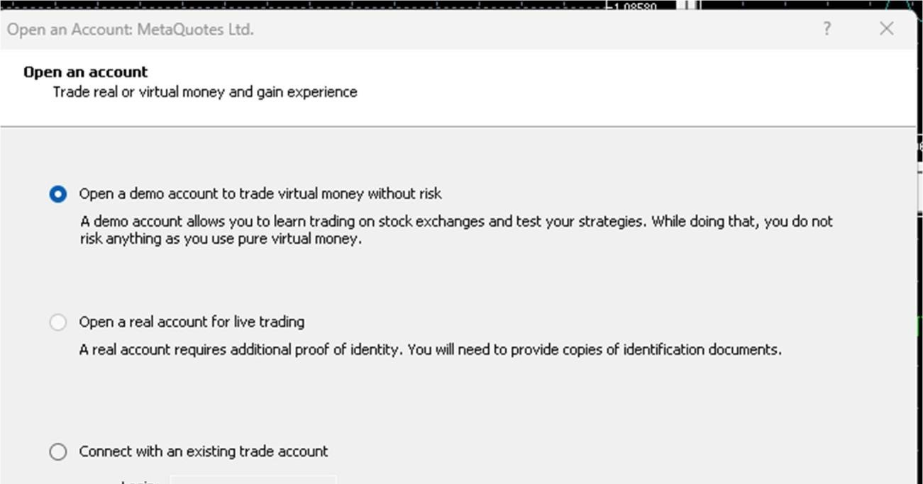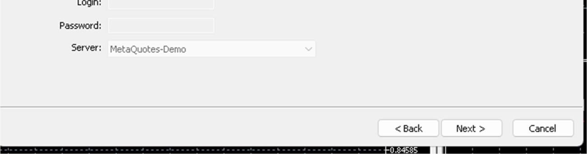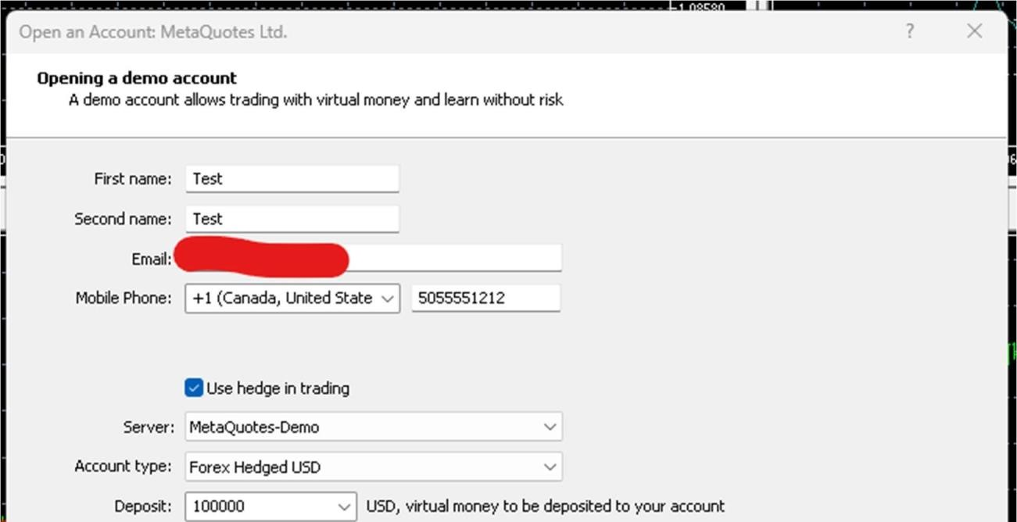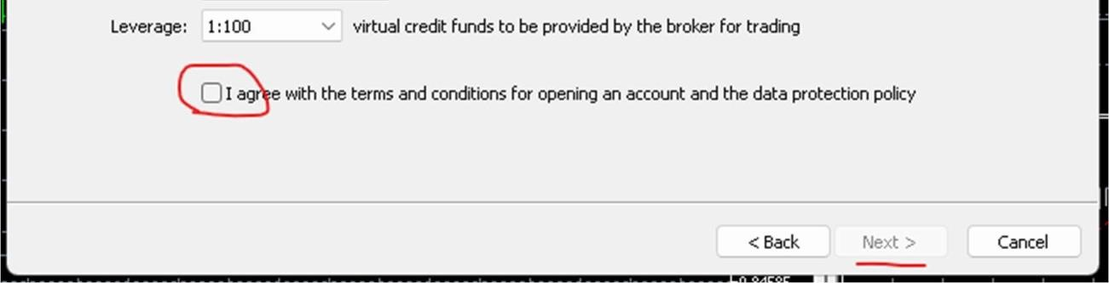

Write down this info as you may need it later on.

